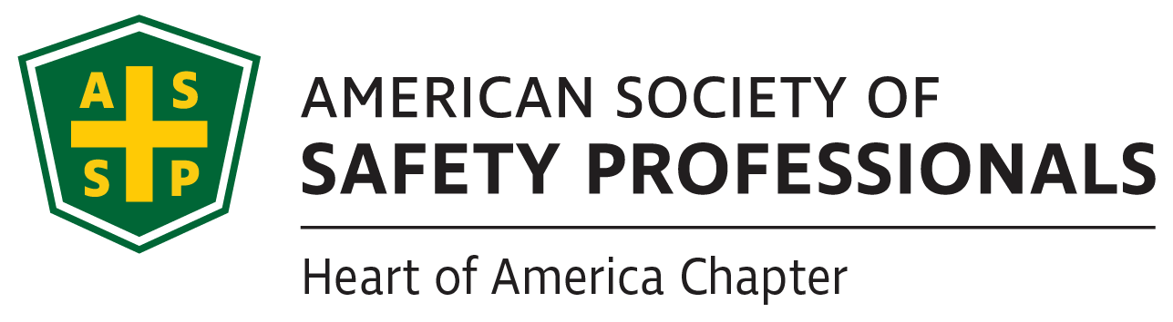

Officers List

President
Tom Metzner, CSP, ARM-P, CFPS

Vice President
Pam Sinatra

Secretary
Robbie Collins, CSP

Treasurer
Shelly Killingsworth, CHMM, CSP

Past President
Chris Cygan, CSP

Website/Social Media
Dave Hallerud, ALCM

Member Engagement
Kristin Danner, CSP

Newsletter Coordinator
Robbie Collins, CSP

Liaison for Student Chapters
Shelly Killingsworth, CHMM, CSP

Members at Large
Ravi Narayan, CSP, ARM
David Hallerud, ALCM

President’s Message
August 2019
On behalf of the Heart of America Chapter executive committee, I want to welcome you to the start of the 2019-2020 term! We’ve been hard at work selecting pertinent topics, presented by recognized subject matter experts.

Before I jump into some of the highlights you can look forward to this term, some recognition is in order. A little trivia: of the 15 Chapters in our Region, Heart of America is the oldest, celebrating 80 years this year!

Every time I talk to new (and present) members, I learn more about their life experiences and expertise. Our Chapter has an incredible knowledge bank, representing diverse industries. Please use the monthly meetings as an opportunity to network and exchange business cards with other members.

Similarly, please extend a hand and introduce yourself to students from UCM and Pitt State, our two student chapters. Students are not always able to attend our monthly meetings due to class schedules, but we’re always excited to have them.

Instead of doing a big, two-day professional development conference, we’re trying something new this term. We have selected three speakers to present after regularly scheduled monthly meeting (starting in January). Similar to the PDC, you’ll be eligible for continuing education points, but it won’t involve being away from your office for two days. Look for more information in the upcoming newsletters.

2018-2019 was an exciting term because we achieved our second consecutive year as a Platinum Chapter. With your support, we’re looking forward to continued success and achieving Platinum status again this year!

Hope to see you at our first meeting on September 13th, for an OSHA update presented by Todd Sieleman. In the meantime, please feel free to reach out to me or anybody on the executive team with ideas or suggestions.

Tom Metzner
ASSP HOA Chapter President

Edition 81, Volume 1
08/07/2019

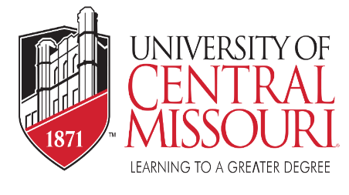
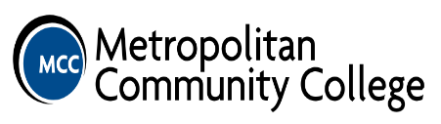
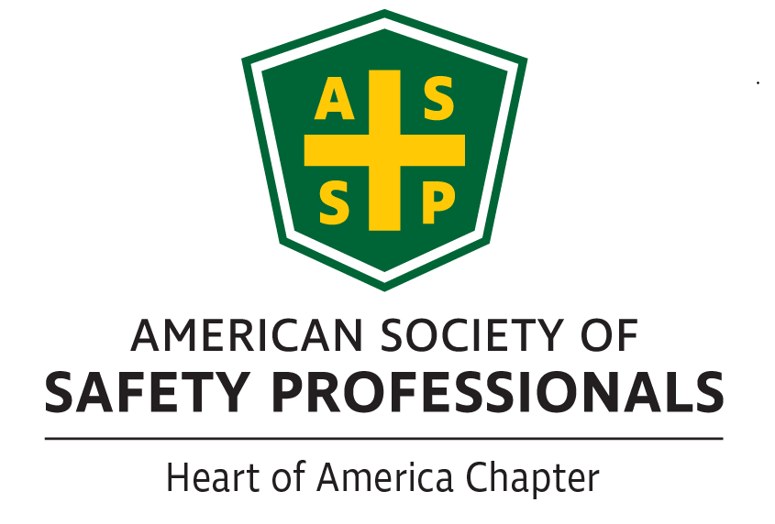
New Members

- James Barry, EH&S, Independence Power & Light
- Adam Grace, Senior EH&S Specialist, Garmin
- Jamie Hofer, WC Manager Processes, YRC Worldwide
- Eric Holder, EH&S, Independence Power & Light
- Jarrett Kreisel
- Chad LaVoi
If you know someone who would like to join ASSP Heart of America Chapter please direct them HERE!
ASSP Safety 2019 Photo
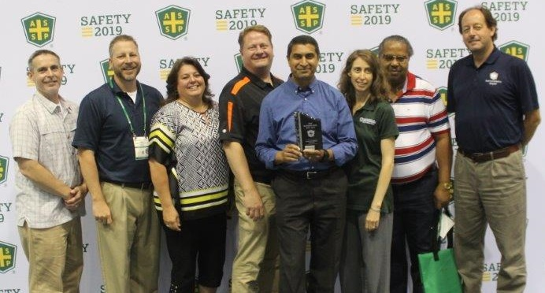
Job Openings

Please check out our website for recent job postings. https://kc.assp.org/

Kimray - Director of HS&E – Oklahoma City, OK https://kimray.com/careers/post/1216

Next Meetings

September 13th: OSHA Update
October 21st: Fleet Safety at the Zoo
November 8th: Total Worker Wellness at Lockton (in conjunction with a blood drive)

Medical Marijuana – A hot Topic in the Workplace?
By now, most of you have encountered or at least heard about someone involved with or using medical marijuana while at work. This seems to be one of the hottest buzz words today. And, despite individual opinions on the topic, there are many questions that exist from a safety perspective on how to handle medical marijuana in the workplace. The best approach for businesses is to stay up-to-date on this constantly changing front. Below are several links to help aid employers when it comes to this challenging issue.
- Haze of Confusion - How employers and insurers are affected by a patchwork of state marijuana laws

- Medical Marijuana and Your Employees

- Marijuana - A Medical Perspective

- Why Marijuana Impairment Testing Must Be Made a Priority in Workers’ Comp

Training
Sponsored by ASSP Mid-Missouri ASSP
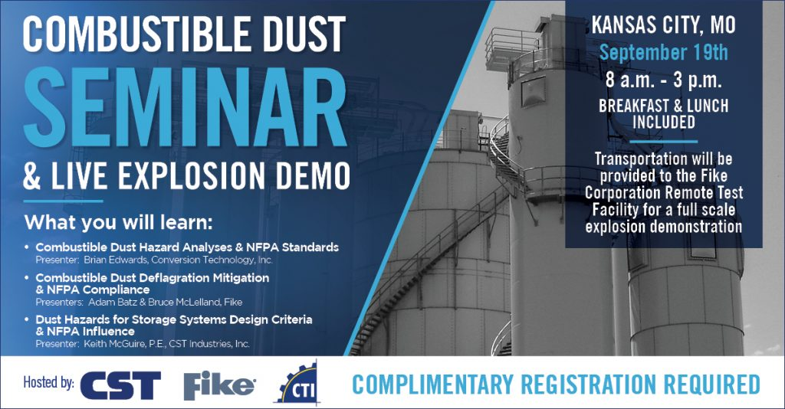

Free Combustible Dust Seminar, With Live Explosion Demo
COMBUSTIBLE DUST SEMINAR | September 19th | Kansas City, MO
Conversion Technology Inc. has teamed up with the Fike Corporation and CST to co-host an educational seminar on the ever-growing topic of dust hazards, NFPA Compliance, design approaches and retrofit issues.
Breakfast and lunch will be provided. Immediately following the presentations there will be a LIVE EXPLOSION DEMO!
*Registered attendees who have completed, signed and returned the required forms will be transported to the Fike Corporation remote test site facility for the live demonstration.
REGISTER today via email to dusthazardseminar@cstindustries.com
For more information on Combustible Dust Hazards, please visit us at conversiontechnology.com or call us at 770-263-6330.
* Additional approvals may be required prior to attending. You must wear closed-toe shoes. Eye and ear protection will be provided. No photos or videos may be taken at the remote test site.
GET MORE INFORMATION

Executive Committee

Executive Committee contact information. We always welcome questions, comments and suggestions.
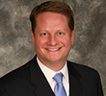  President – president@kc.assp.org  Tom Metzner | 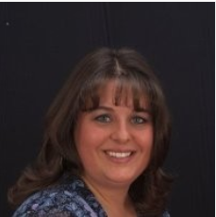  Treasurer – treasurer@kc.assp.org  Shelly Killingsworth
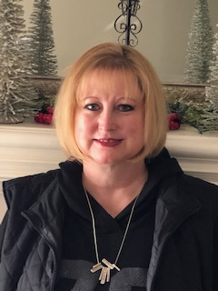  Vice-President – vp@kc.assp.org  Pam Sinatra | 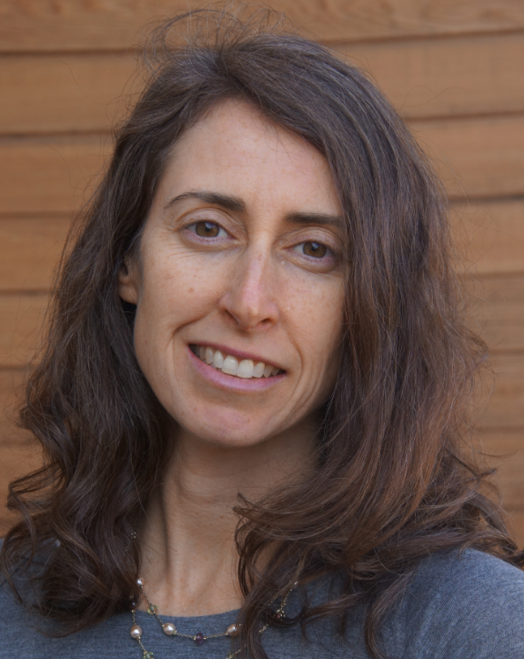  Member Engagement  Kristin Danner
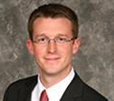
Secretary – secretary@kc.assp.org
Robbie Collins

