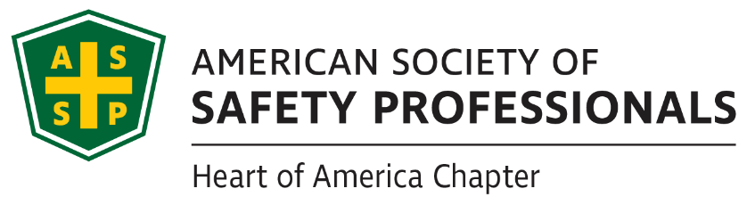

Officers List

President
Derek Farmer, MBA, CSP

Vice President
Christian Howell

Secretary
Mindy Prichard, CSP

Treasurer
Ravi Narayan, CSP, ARM

Past President
Tom Metzner, CSP, ARM-P, CFPS

Website/Social Media
Dave Hallerud, ALCM
Derek Farmer, MBA, CSP

Member Engagement

Newsletter Coordinator
McKenzie Turner

Liaison for Student Sections
Phil Shoemaker, CSP, CRIS, CHST

Members at Large
David Hallerud, ALCM

President’s Message September 2023

Dear Heart of America Chapter Members,

I hope this message finds you well and refreshed as we bid farewell to the scorching summer temperatures. As we welcome September, it's with great enthusiasm that I share some exciting updates about the Heart of America Chapter.

While the weather is cooling down, our chapter is heating up with a series of engaging events lined up for the rest of 2023, and we're already hard at work finalizing plans for 2024. If you or your company have an interest in speaking or hosting our chapter, please don't hesitate to reach out. Your insights and contributions are invaluable to our community.

Over the past couple of months, I had the privilege of attending two Women in Safety Excellence (WISE) meetings in July at Charlie's House and August at Girls on the Run. These are two outstanding non-profits dedicated to safety education, mentorship, and empowering young women in our community. It's experiences like these that reinforce the importance of our involvement in ASSP.

As we look to the future, our chapter is actively seeking volunteers to join our Executive Committee. We have opportunities for individuals who can assist in meeting preparations, support WISE initiatives, and collaborate with other Committee Chairs on their monthly tasks. If you're interested in getting involved or would like more information about these opportunities, please reach out to me at president@kc.assp.org.

One of the most promising signs of our chapter's growth is the addition of over 40 new members since May. This growth not only strengthens our community but also expands the opportunities for networking and engagement with professionals across the Kansas City Metro area. If you know someone in the region who would benefit from our chapter, please extend an invitation to our next meeting. Their first meeting is on the house, and we're excited to welcome them into our ASSP family.

As we embrace the transition to cooler temperatures, let's also look forward to the exciting times ahead for our chapter. Your involvement, enthusiasm, and commitment continue to drive our success, and I'm thrilled to be a part of this journey with all of you.

Derek Farmer, MBA, CSP

Edition 85, Volume 2
September 15, 2023

August Chapter Meeting: Electrical Safety Simplified

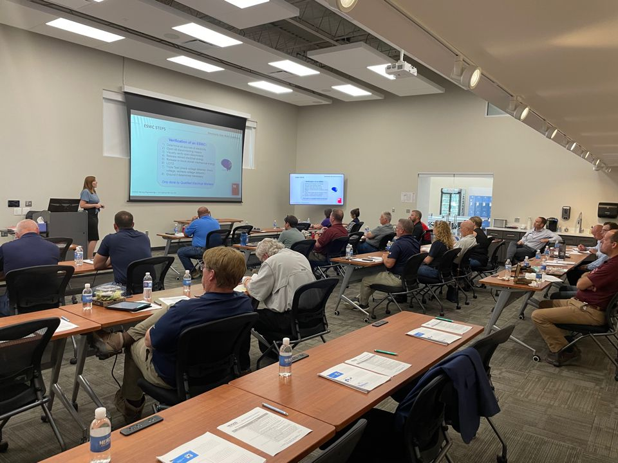
Our August Chapter Meeting had a great turnout at Herzig Engineering in Kansas City, MO. Caitlyn Hetzel presented “Electrical Safety Simplified”. She was able to speak about such a crucial aspect of workplace safety. It is important to bring awareness and understanding of electrical safety to our employees and the more we do that, the more likely we are to prevent such awful injuries and fatalities from occurring in the future.
ChapterWISE August Meeting: Charlie’s House
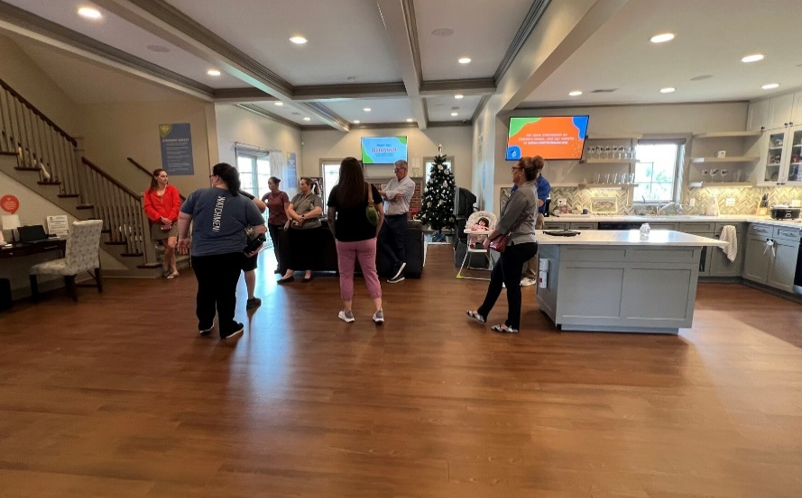
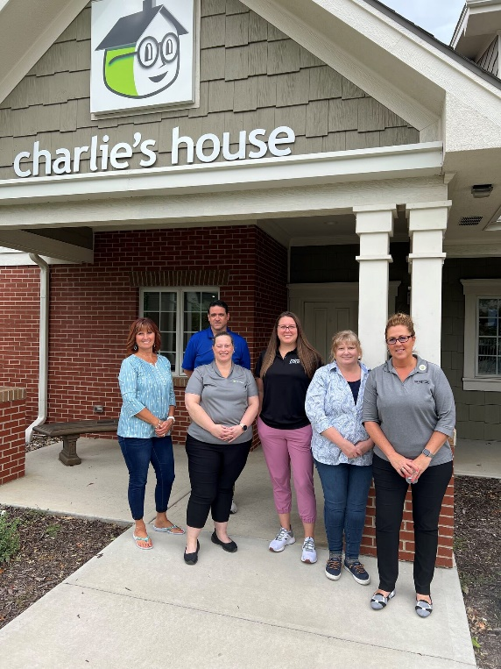
Charlie's House is a charitable organization founded by the parents of Charlie Horn. At 2 years old, Charlie was fatally injured when he climbed on a 30" dresser. The dresser fell over onto him causing him to die by suffocation from the weight of the dresser. Even though the dresser was small and not very heavy, a falling dresser can come down with up to 400 pounds of force on a child. The tour highlighted several dangers that most of us would never think of.

For example, do you know how many devices within your home contain a button battery? And are you aware that a button battery is not just a choking hazard, but can implant itself into the stomach of a child causing erosion and internal bleeding? This can be fatal.

Charlie's House is fully funded by donors. It opened in 2020. They provide all safety devices for free.
For more information or if you would like to schedule an individual tour, you can do so online at www.charlieshouse.org.

Heart of America Chapter donated to Maui Wildfire Relief Efforts


The Heart of America Chapter recently donated $500 dollars to the American Red Cross to help with the wildfire relief efforts in Maui. It is truly the support from our chapter and membership dues that allows this to take place. Helping others in need from natural disasters around the U.S. is a massive cause that the chapter is honored to be able to help with. Thank you to all of our members!

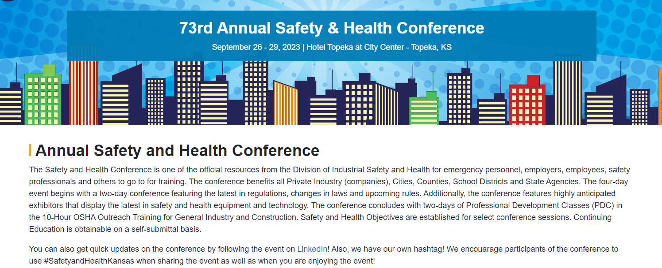
73rd Safety & Health Conference in Topeka, KS

ASSP Community Interest Group – Heart of America ChapterWISE
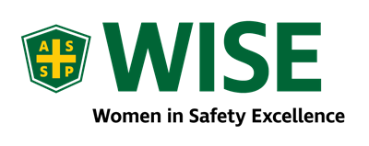  Contact Karen Santoyo for more information:  karen.santoyo@examinetics.com | ASSP’s Women in Safety Excellence (WISE) is a common interest group that advances ASSP members and the safety profession through education, mentorship, networking, collaboration, research, and innovation. With over 2,000 members, WISE provides member and community support and collaborative opportunities within the profession. WISE works to bring awareness to the following industry topics:  - The need for proper fitting personal protective equipment for women in the workplace  - Workplace violence against women, which is the number one cause of fatal injuries to women in the workplace.  - To bring awareness to women in leadership roles in safety and to mentor others to help them achieve their goals

Upcoming HOA Chapter Meeting Calendar – Save the Date!

Friday, September 22nd, 2023 | Innovation Center – Lee’s Summit, MO  11:30am to 1:00pm  1101 Innovation Parkway, Lee’s Summit, Missouri, 64086 | Human Factors: The Science of Safety  Presented by Mark Heidebrecht “Ergo Mark”  This presentation covers the human factors research behind many of the common things we consider to be in the “field of Safety”.
October 20th, 2023 | John Knox Village  11:30am to 1:00pm  1001 NW Chipman Rd, Lee's Summit, MO 64081 | Anatomy of Post Incident Care – Panel Discussion
November 16th, 2023 | Scheels  11:30am to 1:00pm  6503 W 135th St STE 88, Overland Park, KS 66223 | OSHA Update
December 8th, 2023 | Harvester’s  1:30pm – 3:30pm  3801 Topping Ave, Kansas City, MO 64129 | Volunteer Event  We will meet and help pack or organize shipments of goods for Harvester’s to support their mission and ours to give back to the local community.

ChapterWISE – Women In Safety Excellence
Monday, September 25th, 2023 | Virtual Teams Meeting | Monthly Meeting  Lead by Karen Santoyo

Local Community Events
September 15th, 2023 | Construction Safety Group of KC Scholarship Golf Tournament  Hosted by the Construction Safety Group of KC  Shoal Creek Golf Course – Kansas City, MO  Flyer
September 19th and 20th, 2023 | 30th Annual Missouri EHS Conference  Hosted by the Missouri Association of Manufacturers  Adams Pointe Conference Center – Blue Springs, MO  EHS Conference | Mamstrong
September 26th -29th, 2023 | 73rd Annual Safety and Health Conference  Hotel Topeka at City Center – Topeka, KS  Annual Safety and Health Conference - Kansas Department Of Labor (ks.gov)

September Upcoming Safety & Health Events to Remember

September
September | National Preparedness Month | Federal Emergency Management Agency | September is National Preparedness Month.pdf
September | Autumn Safety | National Safety Council | Autumn Safety Home - National Safety Council (nsc.org)
September | School Bus Safety | National Highway Traffic Safety Administration | School Bus Safety | Bus Stops, Drivers | NHTSA
September | National Suicide Prevention Month | Department of Homeland Security | September is National Suicide Prevention Awareness Month | Homeland Security (dhs.gov)

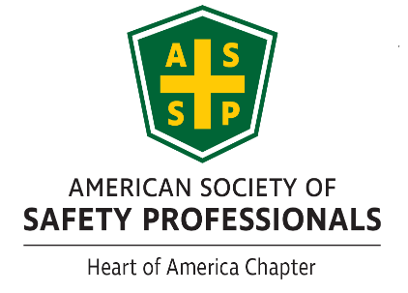

New Members

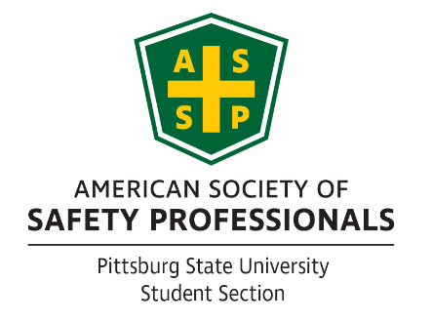
Please welcome: Jennifer Adams, Jose Martinez, Cade McNeely, Christian Turner, Myron Ashley, Vaughn Baker, Roy Garcia Jr., Linda Glass, Michael Kay, Benjamin Rodgriduezbrockus, Andrew Turner, Daniel Kenyon, Maureen Mwendia, Ben Schwaller, Eliab Cifuentes, Bryson McCaleb, Zach Potthoff, Elijah Smith, Francisco Acosta, Maria Bedarte, Mike Combs, Jason Cranz, Brittany Dickmeyer, Cassandra Flores, Paul Johnston, Tyler Laughlin, Harrison Miller, Sidney Nigro, Daniel Quintanilla, Dennis Stanley, Dalia Wellens, Scott Smith, Eli Viloria, Scott Smith, Joe Baranski, Andrew Chance, Kay Conat, Justin Esquivel, Mike Freeman, Jeremy Gremminger, Kate Jones, David Linthacum, Nathan Muenz, Erin Riley, Kathy Zents, Aaron Bundy, Ashley Craddock, Charles Dempsey, Clinton Gregg, Collin Ring

Many of us are members of associations and groups that involve safety, health, environmental protection, and risk management advancement. As we engage with our member organizations, remember to network and share the opportunities and benefits available within the Heart of America Chapter of ASSP for members, non-members, and our community.
If you know someone who would like to join ASSP Heart of America Chapter please direct them HERE!
ASSP Community
Please take a moment to reach out and connect through ASSP Community.

Job Openings
If you or someone that you know in the safety profession are looking for employment, jobs openings are posted on our Chapter website. Please check out our website for recent job postings. https://kc.assp.org/

Looking for a Job?
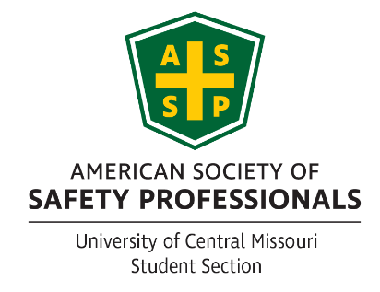
If so, then send your resume to president@kc.assp.org

Upcoming Events
The Chapter website provides information regarding upcoming events and training held by our Chapter, other ASSP Chapters, ASSP, and from other organizations with safety, health, environmental and risk management topics that may interest you. Please visit the website regularly to view upcoming events that may not be specifically listed in the newsletter. https://kc.assp.org/
Executive Committee
Executive Committee contact information. We always welcome questions, comments and suggestions.
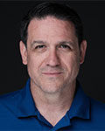  President – president@kc.assp.org  Derek Farmer  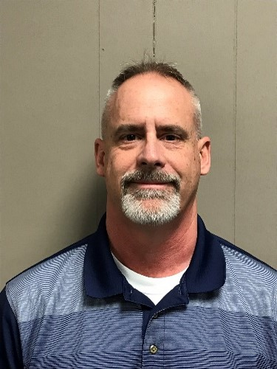 | 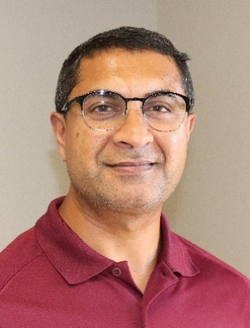  Treasurer – treasurer@kc.assp.org  Ravi Narayan  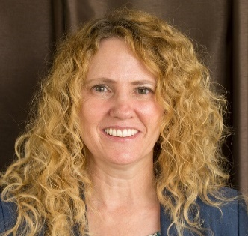
Vice-President – vp@kc.assp.org  Christian Howell  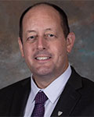  Website and Social Media  David Hallerud | Secretary – secretary@kc.assp.org  Mindy Prichard    Past President  Tom Metzner, CSP, ARM, CFPS

