ASSP HoA Board & Executive Committee Meeting Minutes
March 27, 2025
Call to Order (first/second/time): Mindy/Eric/8:05 am
Board Members Present: Michael Carlson, Mindy Prichard, Ravi Narayan
Executive Committee Members Present: Tom Metzner, Derek Farmer, Eric Hallerud
Guest(s): Ashlie Walker-Deffenbaugh, Quincy Usry – thank you for joining our meeting!!
Approve February Minutes (first/second): Mindy/Mike
Financial Report: Ravi stated the January/February spreadsheet was sent out to the Board and is reconciled. Safety Culture sponsorship is coming to an end. Derek will reach out to Catt Webb. Ravi said the only thing not fulfilled according to the sponsorship letter is that we did not get them a membership because of Jessica Smith’s maternity leave. Their 2nd membership is from Catt. Ravi will check the sponsorship fulfillment and see if we are on track. Derek is approved to go to ROC in St. Louis with Mike next week.
New Business
- COMT Status: 3,960 points – deadline for earning points is June 30th.

- ASSP Meeting Schedule – Mindy
  - March 28 – Speed Meet Event with UCM & PSU – Scheels Training Room – Overland Park
    - Derek organized the Speed Meet portion of the event. 48 signed up.
  - April 25 – Active Assailant Preparedness @ Terracon. Vaughn Baker with Strategos is confirmed speaker. Bio/photo coming this week from Vaughn. They are listed as a Silver Sponsor.
  - May 16 – Contractor Management @ The Builders Education & Training Center presented by Derek. Mindy will announce top 3 winners for “most attended meetings”.
  - Summer Meetings – we discussed having a gathering in June or July and offer free headshots to members. Eric said he could take the pictures and help coordinate event.

- Safety Professional of the Year
  - ASSP – Derek is our nominee for Chapter SPY – congratulations to Derek!
  - Region – Tom is our nominee for Regional SPY, but we do not know who has won, yet.
- Challenge Coins – Status – Tom has them all distributed for this term.
- EC Dinner – TBD – June or July
- Professional Headshots – Discussed a photographer Derek knows, and Mindy found an option through Headshot Pro AI. Maybe an event called, “Shots and Shots” – Eric will coordinate.
- Newsletter – Mike said this is on track with the next one coming mid-April. Strategos is added as a silver sponsor in the newsletter. Article submissions and call for pictures send to Mike.
- Student Section – Phil Shoemaker – not in attendance due to loss of his mother.
  - UCM – Mock Accident Investigation is posted, and announcement was sent out.
  - Pitt State – no new updates

- Google Shared Account – we have found the location, and we all need to start adding files to it.

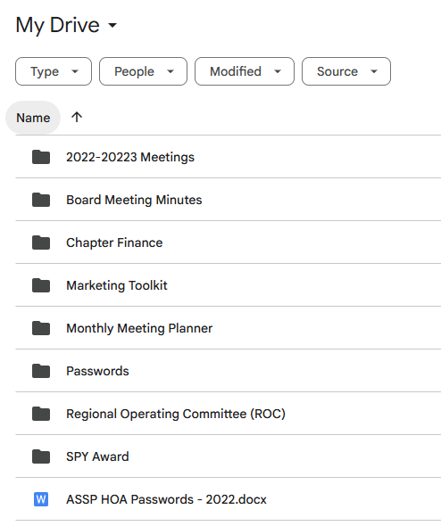
- Transition from VP to President – soliciting now for a VP.
- Annual Membership Survey – Completed. Tom reviewed survey highlights:
  - Topic selections for monthly meetings – doing pretty good. Time of meetings – the majority still like Friday/lunch meetings. Meeting locations – members still in favor of meeting at different venues. Tom also said there were a couple of opportunities/comments to enhance membership, and we will discuss them at the next meeting.
- Committee Reports – discussions on where we are at on committees in place:
Events Coordinator/Vendors: Active | Mindy Prichard
PDW Committee Chair: Active | Mindy Prichard
Social Media/Communications: Active | Derek Farmer
Student Section: Active | Phil Shoemaker / Eric Hallerud
Website Updates: Active | Dave Hallerud
Scholarships: Active | Phil Shoemaker / Dave Hallerud
New Members/Member Engagement: Active | Eric Hallerud – Eric reached out to 5 new members via email but got no responses back. Mike will send Eric a link to a list of new members for future reference. Eric also plans to reach out to Steve Ratliff as he expressed an interest in helping our Chapter.
Newsletter: Active | Mike Carlson
Vendor Promotions: | OPEN – we need someone to recruit for sponsors and keep track of our commitment with current sponsors.
Election Committee: Active | Derek (this position is always done by past present)

- Mindy discussed future events and/or topics for monthly meetings
  - Lunch & Tour at Faith Technologies – Mindy confirmed this can happen with Faith’s Senior Safety Manager, Mark Carlson.
  - Toastmasters Meeting – Ravi as host
Adjourn (first/second/time): Michael/Ravi 8:53 am

